**VPC -01**

1. **Create VPC with 2 private and 2 public subnets.**

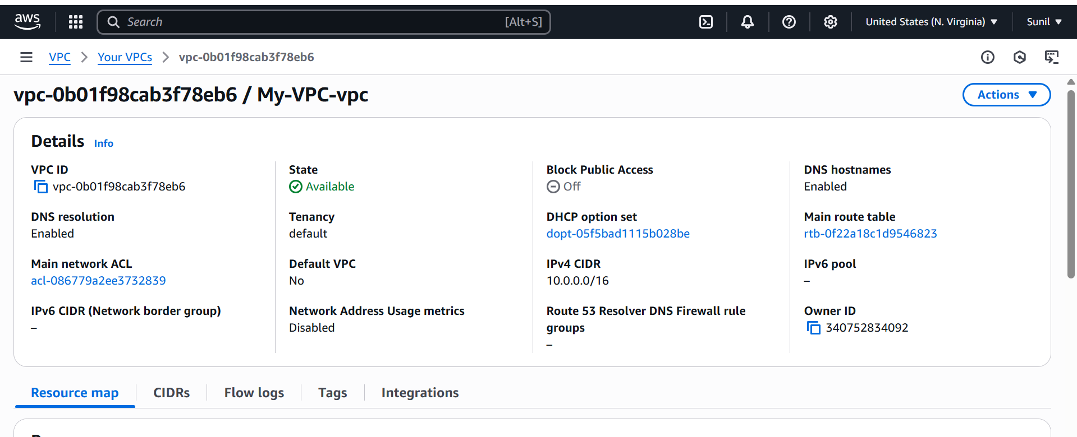

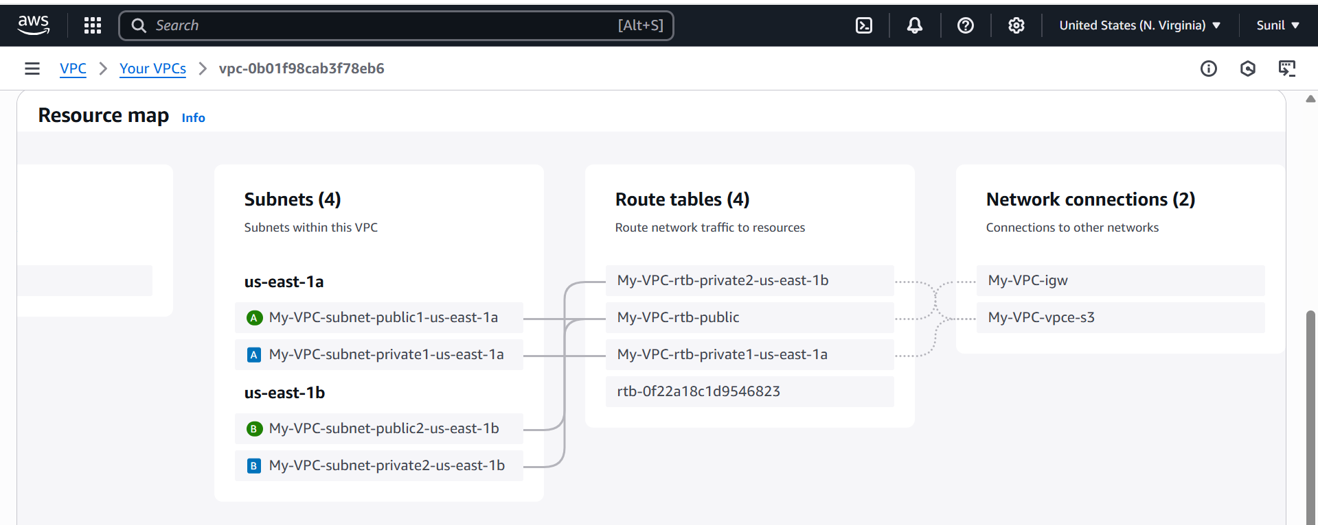

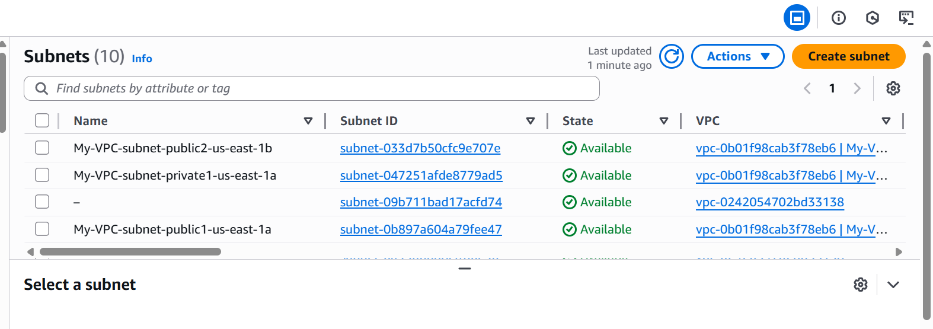

1. **Enable DNS Hostname in VPC**

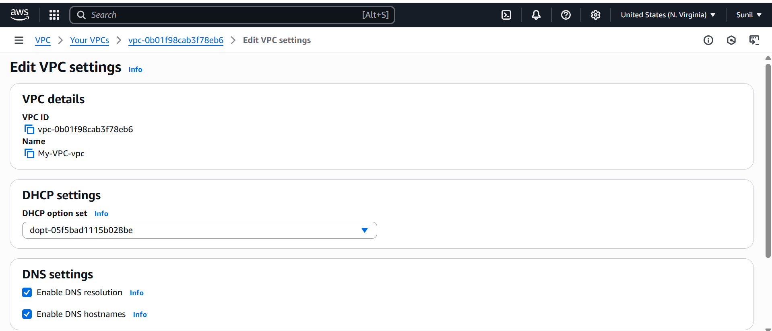

1. **Enable Auto Assign Public ip in 2 public subnets**

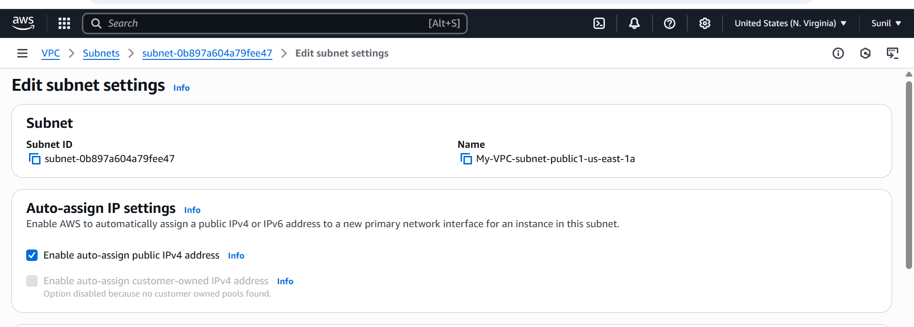

1. **Add 2 private subnets in private route table**

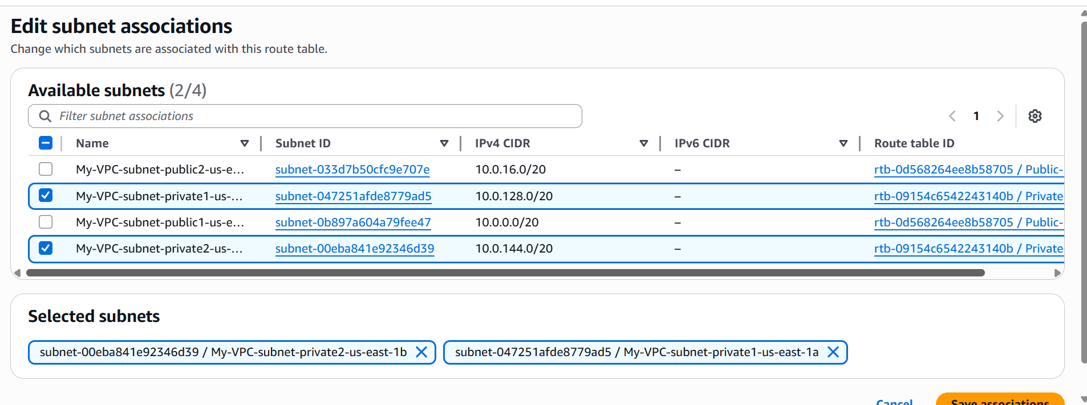

1. **Add 2 public subnets in public route table**

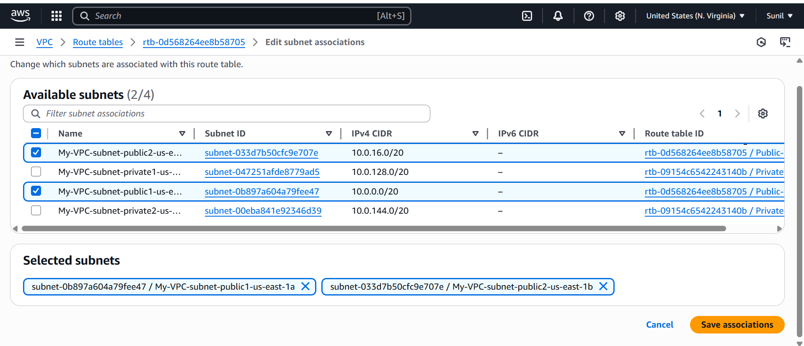

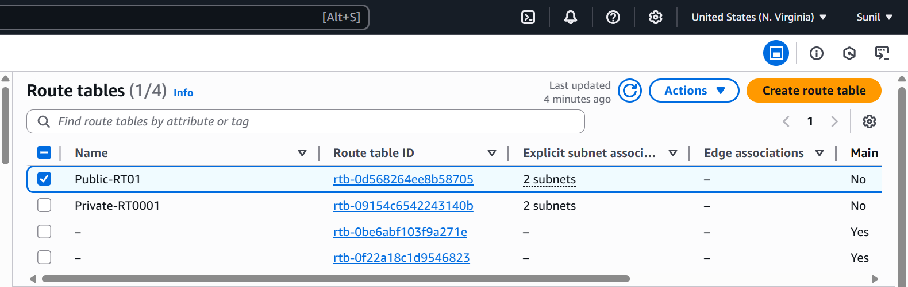

1. **Public route table will have the routes to internet and local**

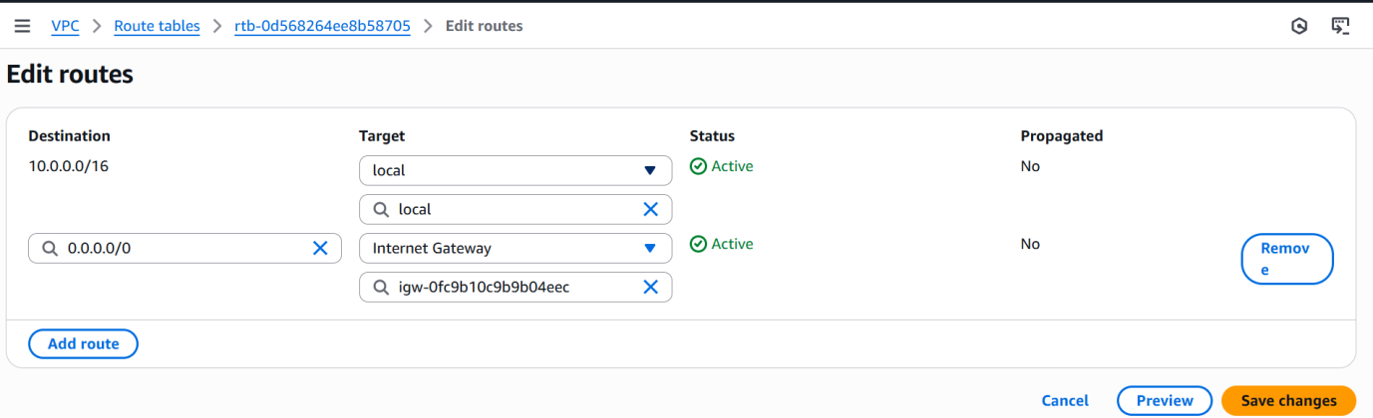

1. **Create Ec2 in public subnet with t2micro and install php**

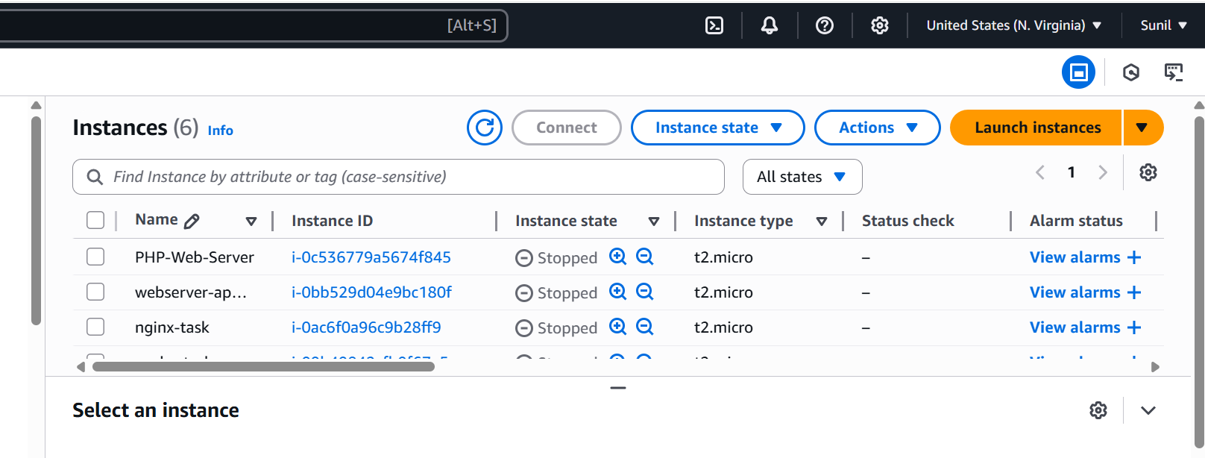

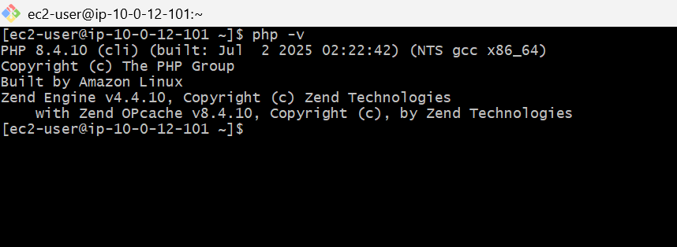

**8) Configure Nat gateway in public subnet and connect to private Instance**

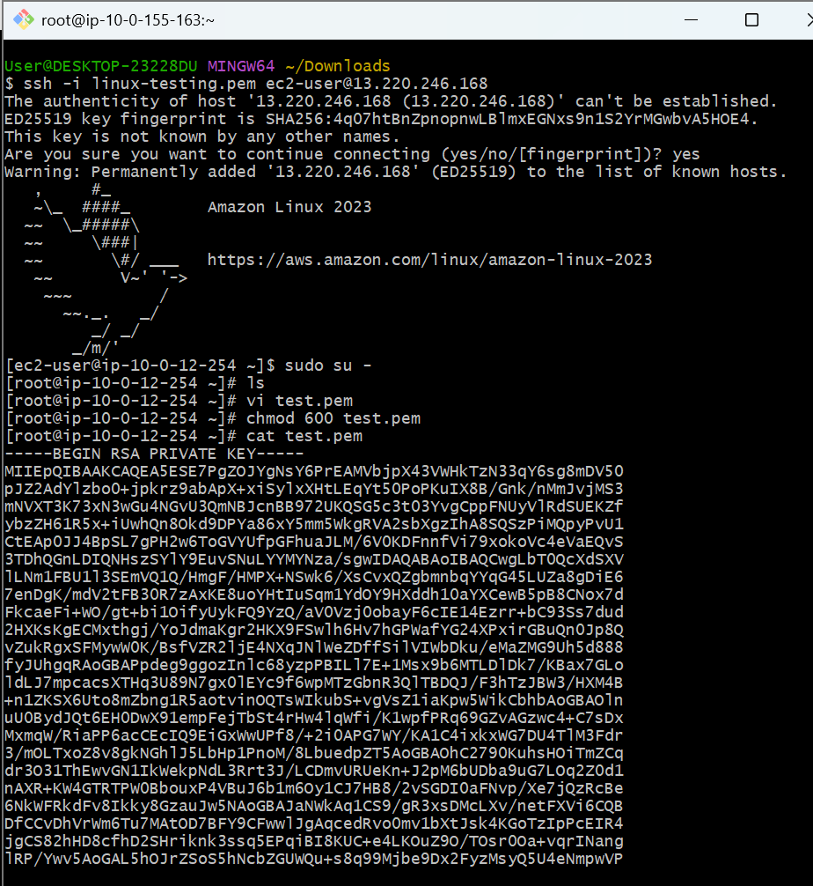

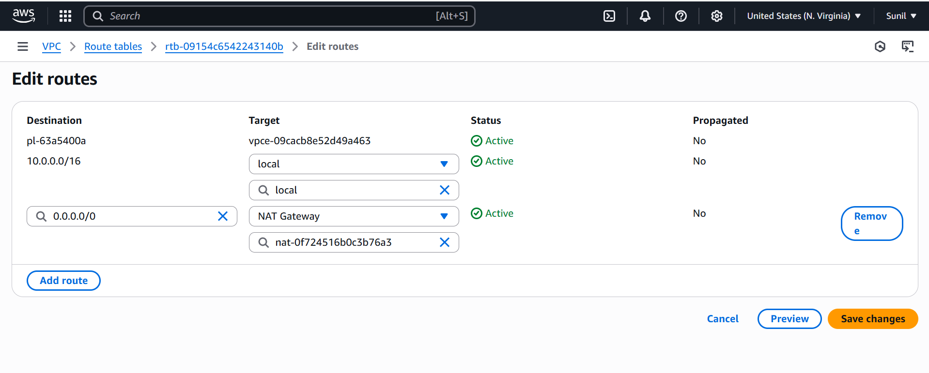

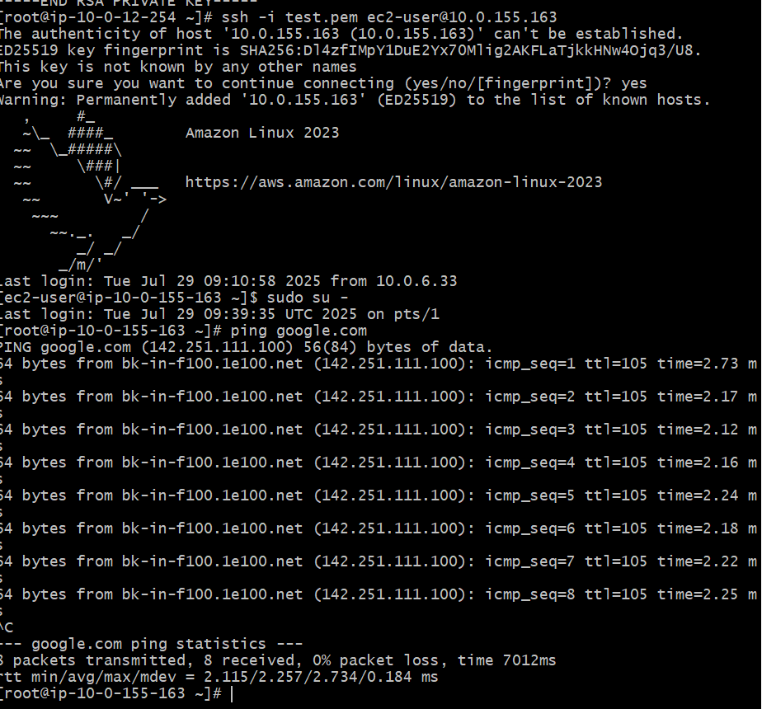

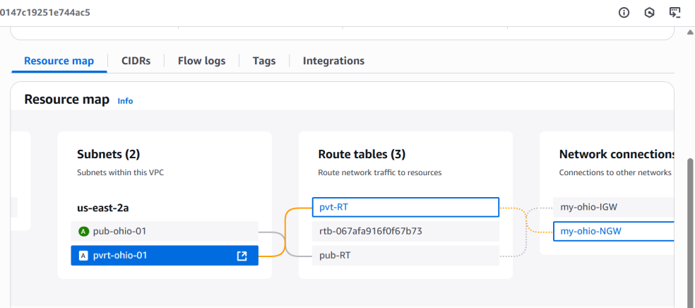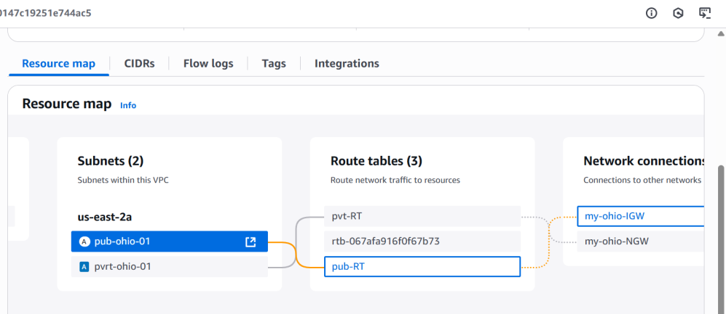

1. **Install Apache Tomcat in private ec2 and deploy a sample app.**

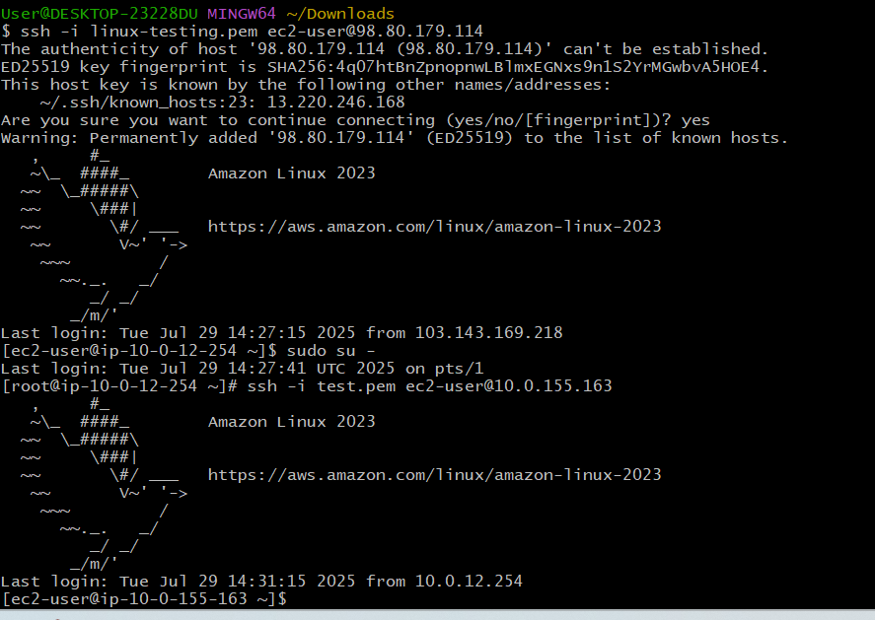

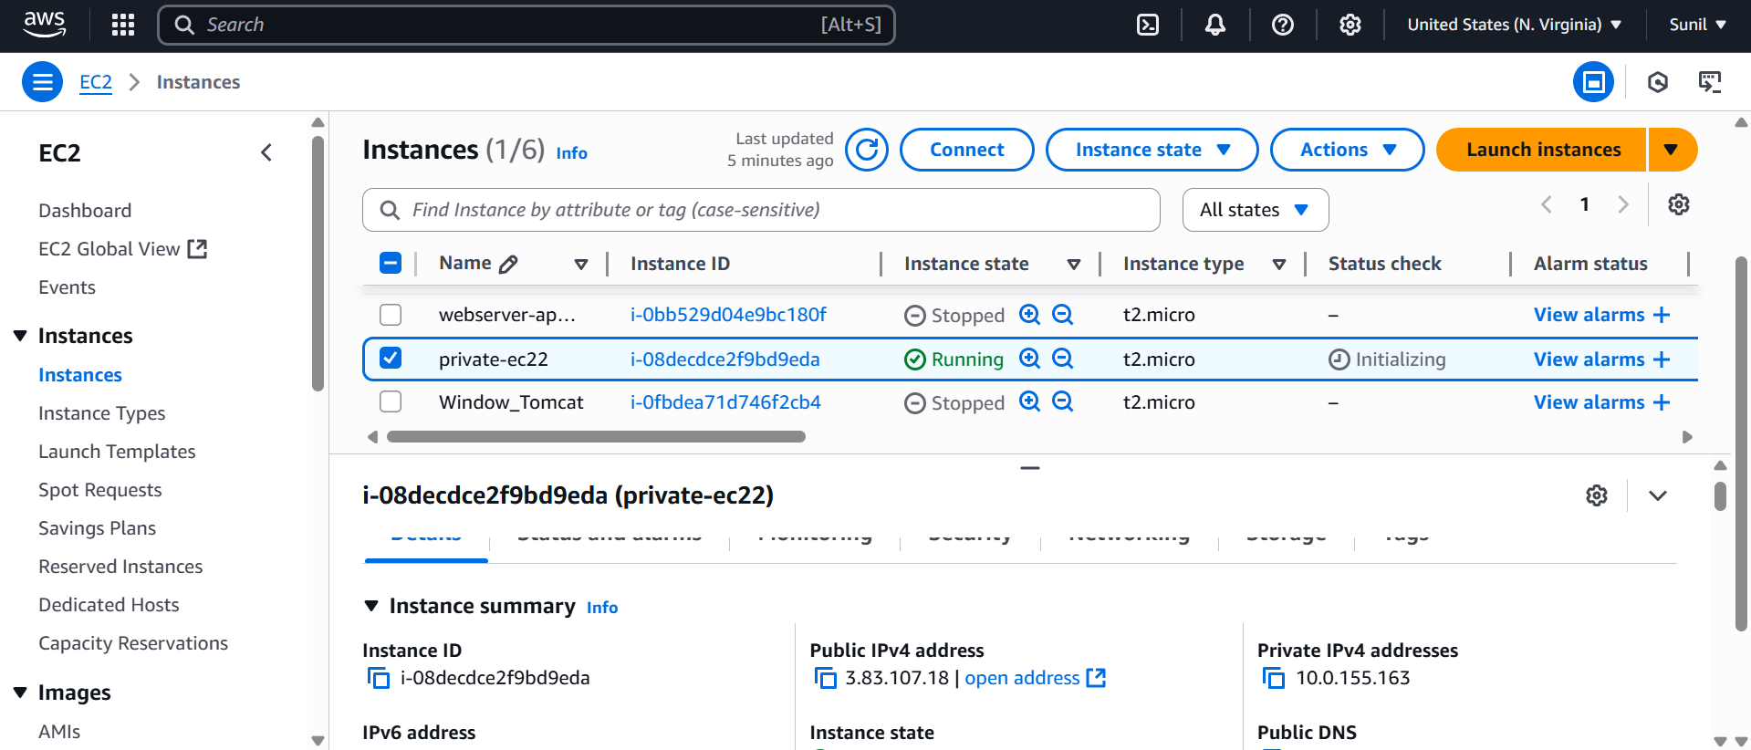

Java install

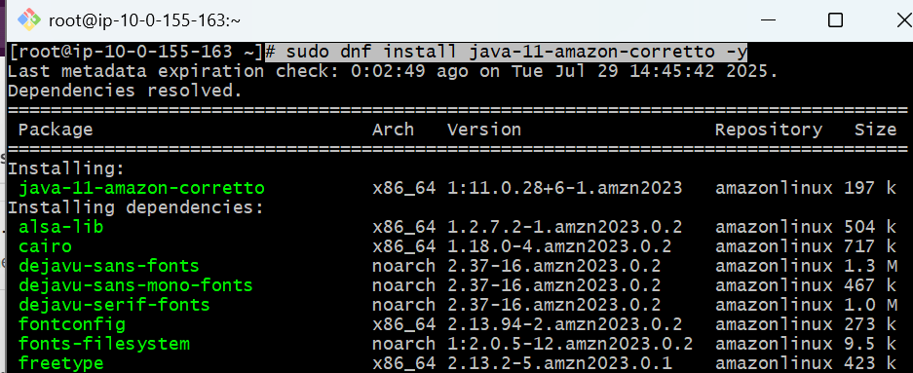

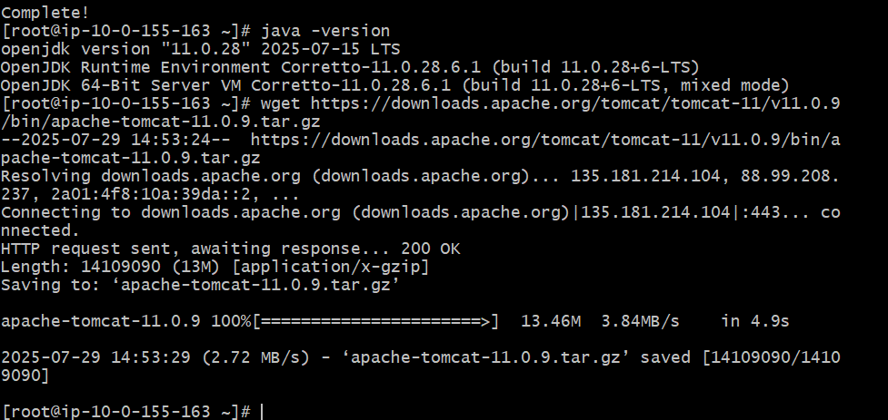

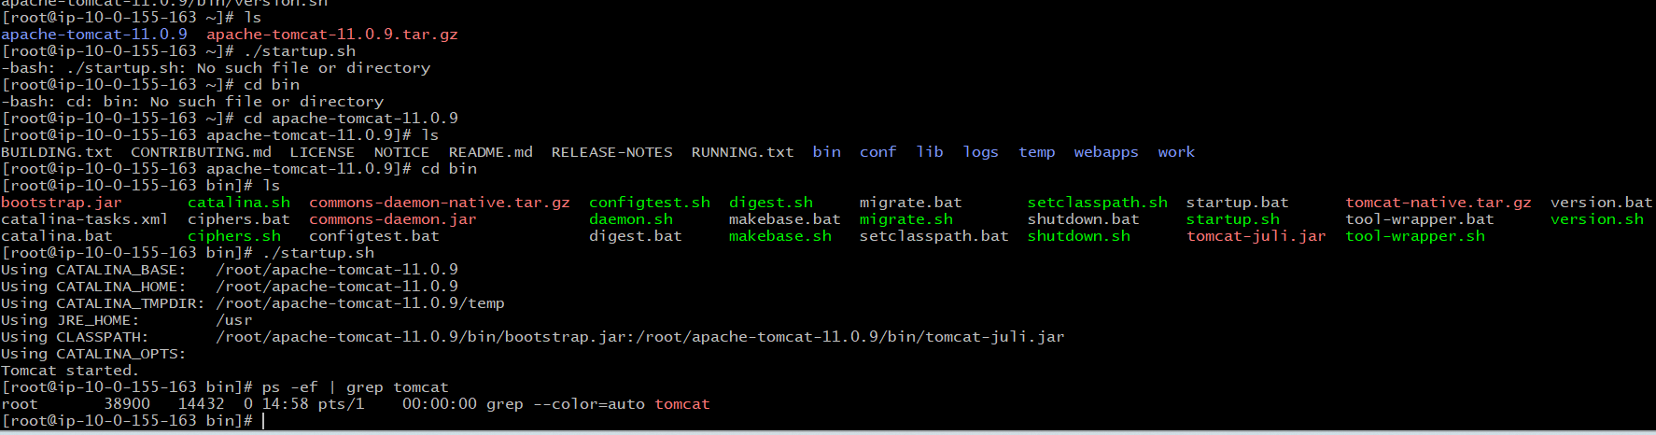

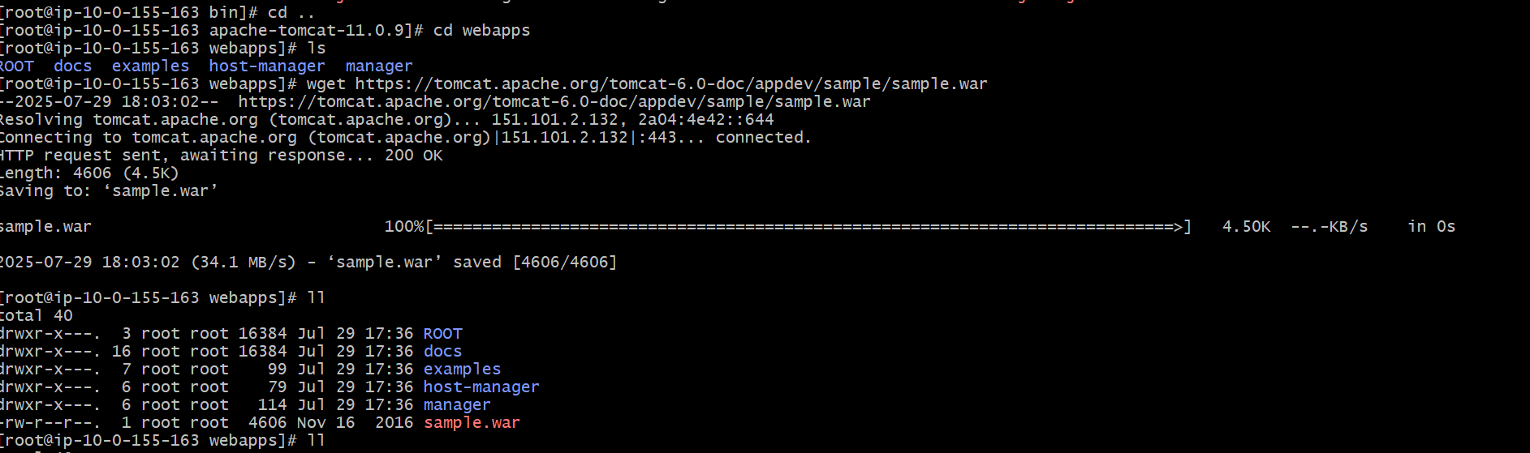

curl <http://localhost:8086>

❌ You **cannot** access a private EC2 directly from your local machine using its private IP.

**Private IPs (e.g., 10.x.x.x)** are not routable over the public internet.

That’s by design — AWS **isolates private subnets** for security.

If you're on your laptop at home, there's no way to reach 10.0.x.x without tunneling or proxying.

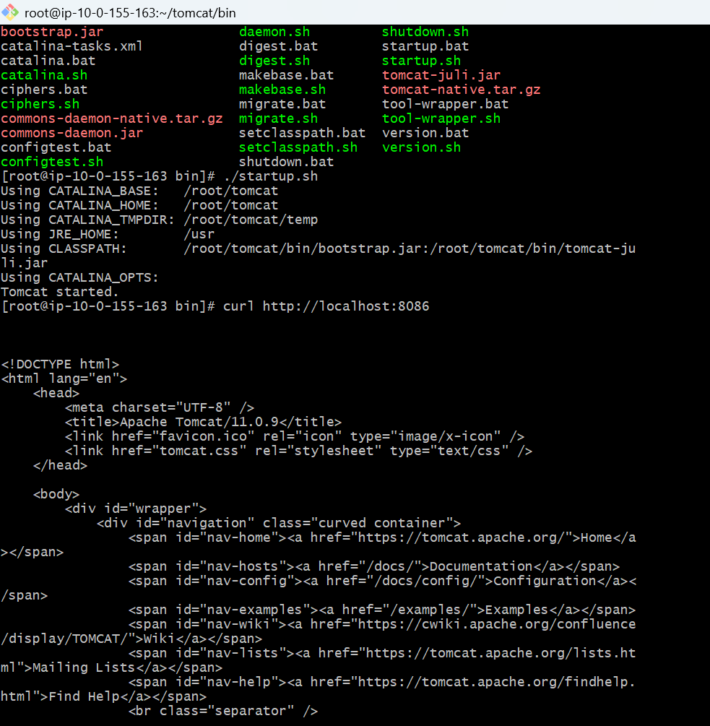

ssh -i linux-testing.pem -L 8086:10.0.155.163:8086 [ec2-user@98.80.179.114](mailto:ec2-user@98.80.179.114)

**Purpose of This Command:**

You're creating a **secure tunnel** from your **local computer** (your laptop or desktop) to a **private EC2 instance**, using a **public EC2 as a jump host**.

This allows you to **open http://localhost:8086 in your browser**, and behind the scenes, it connects to **Tomcat on the private EC2**.

is now creating a secure tunnel from:

* **Your local machine** localhost:8086 →
* **Through the public EC2** (98.80.179.114) →
* **To the private EC2** 10.0.155.163:8086 (where Tomcat is running)

• 98.80.179.114 → your **public EC2's public IP**

• 10.0.155.163 → your **private EC2's private IP**

• linux-testing.pem → your **EC2 private key**, stored **on your local machine**

**Purpose of This Command:**

You're creating a **secure tunnel** from your **local computer** (your laptop or desktop) to a **private EC2 instance**, using a **public EC2 as a jump host**.

This allows you to **open http://localhost:8086 in your browser**, and behind the scenes, it connects to **Tomcat on the private EC2**.

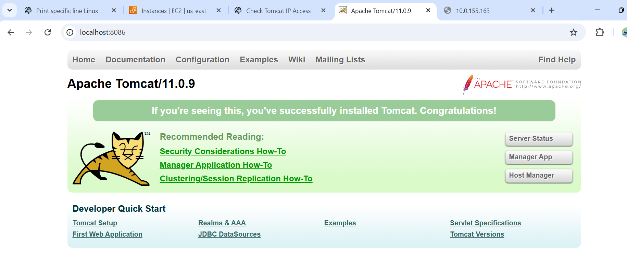

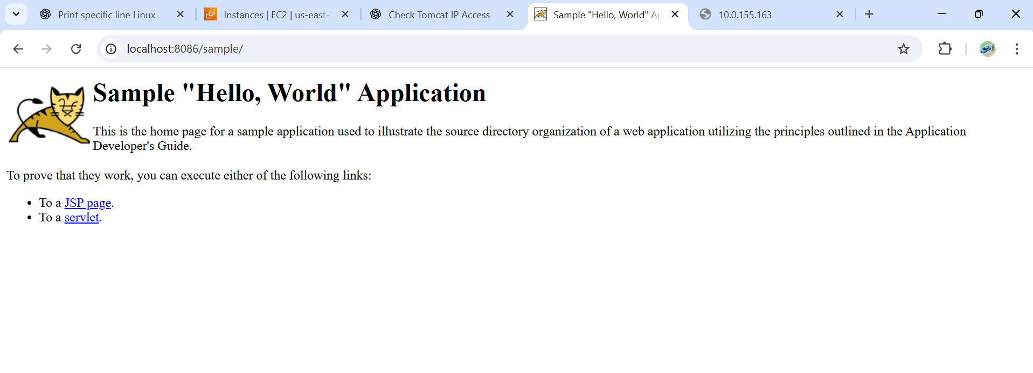

**10)Configure VPC flow logs and store the logs in s3 and CloudWatch.**

First we have to create a flowlog for s3

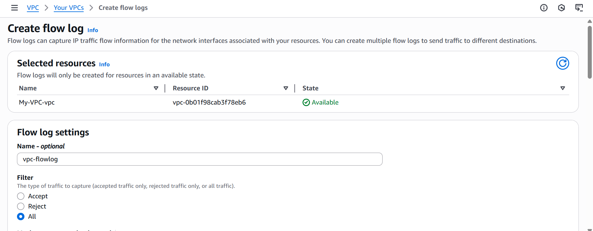

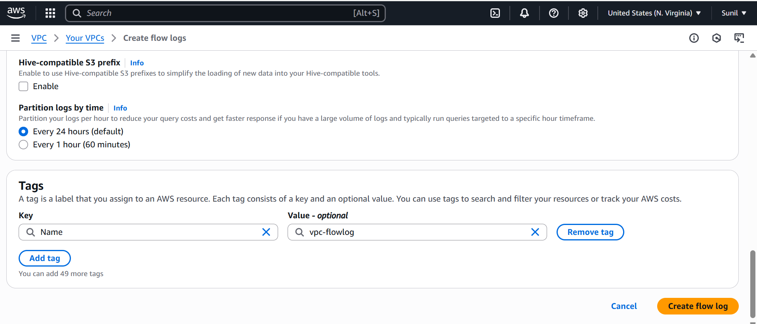

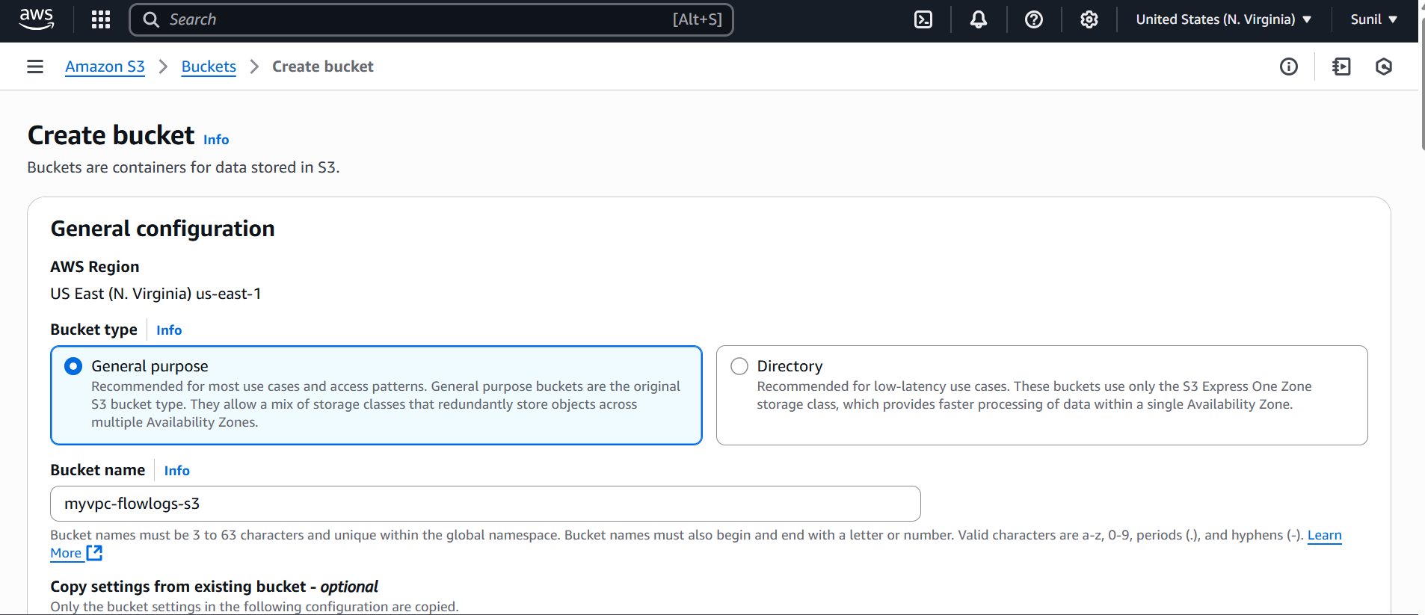

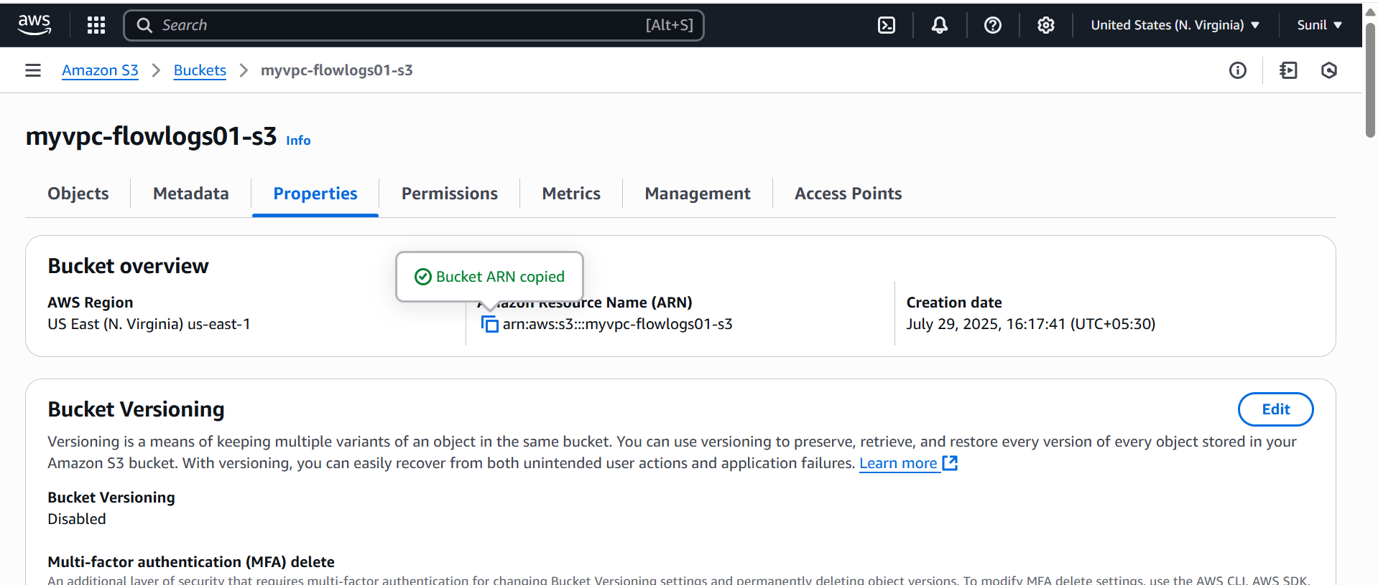

**Flow logs of s3**

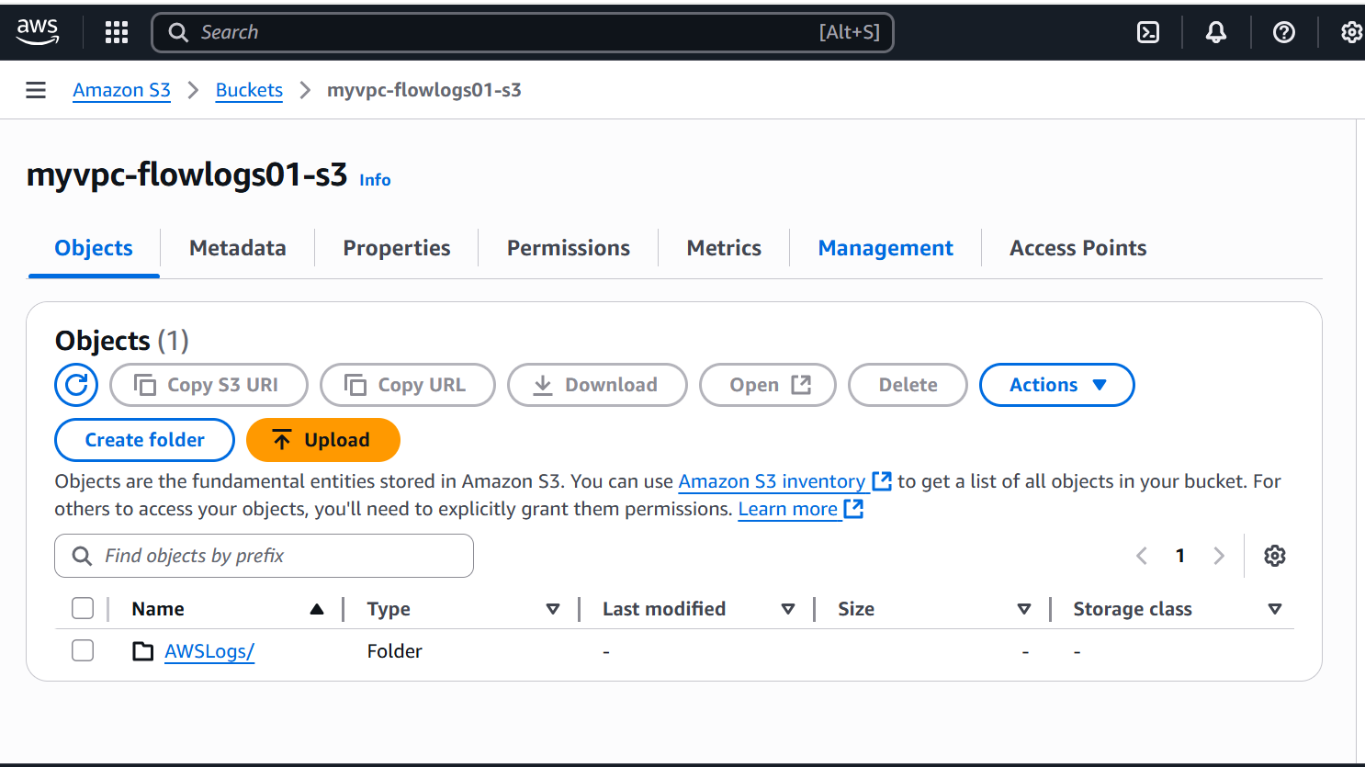

Cloudwatch

create a flowlog for Cloudwatch

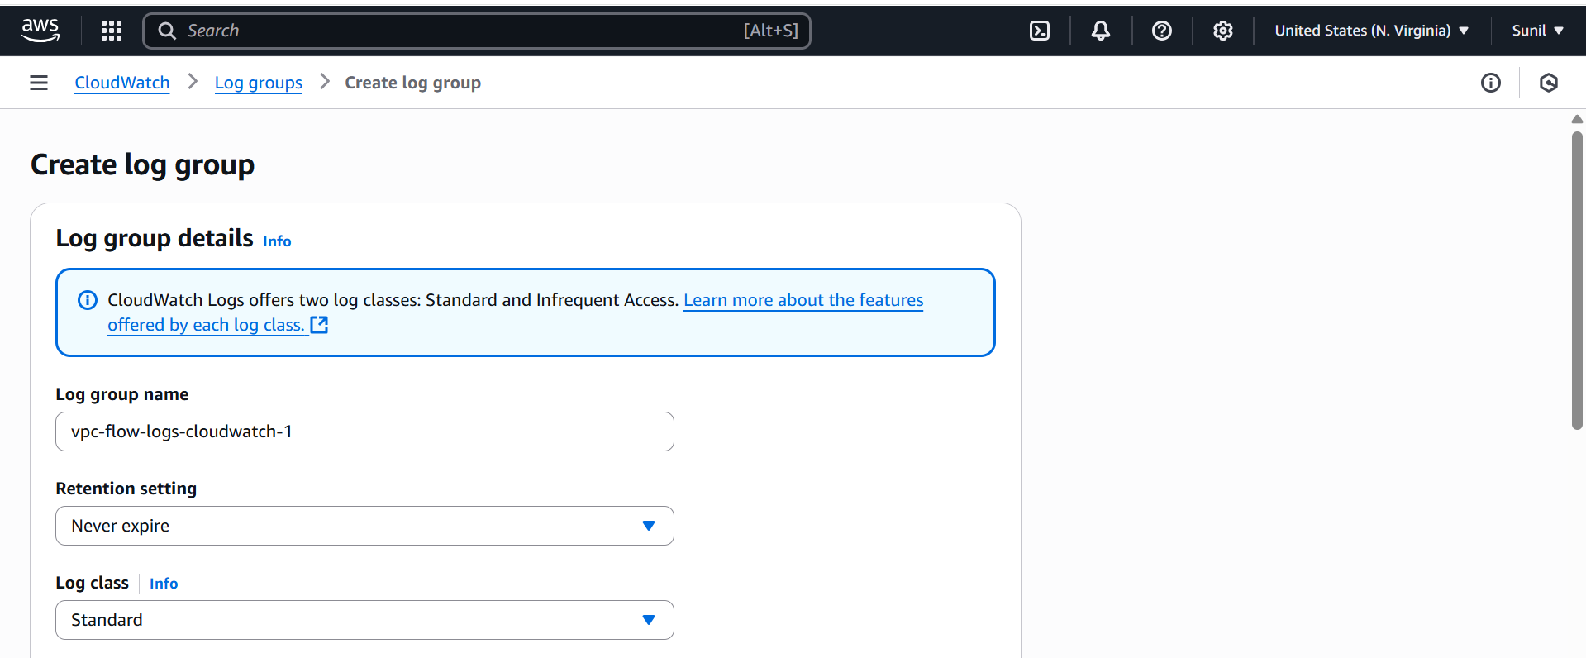

First we have create a policy

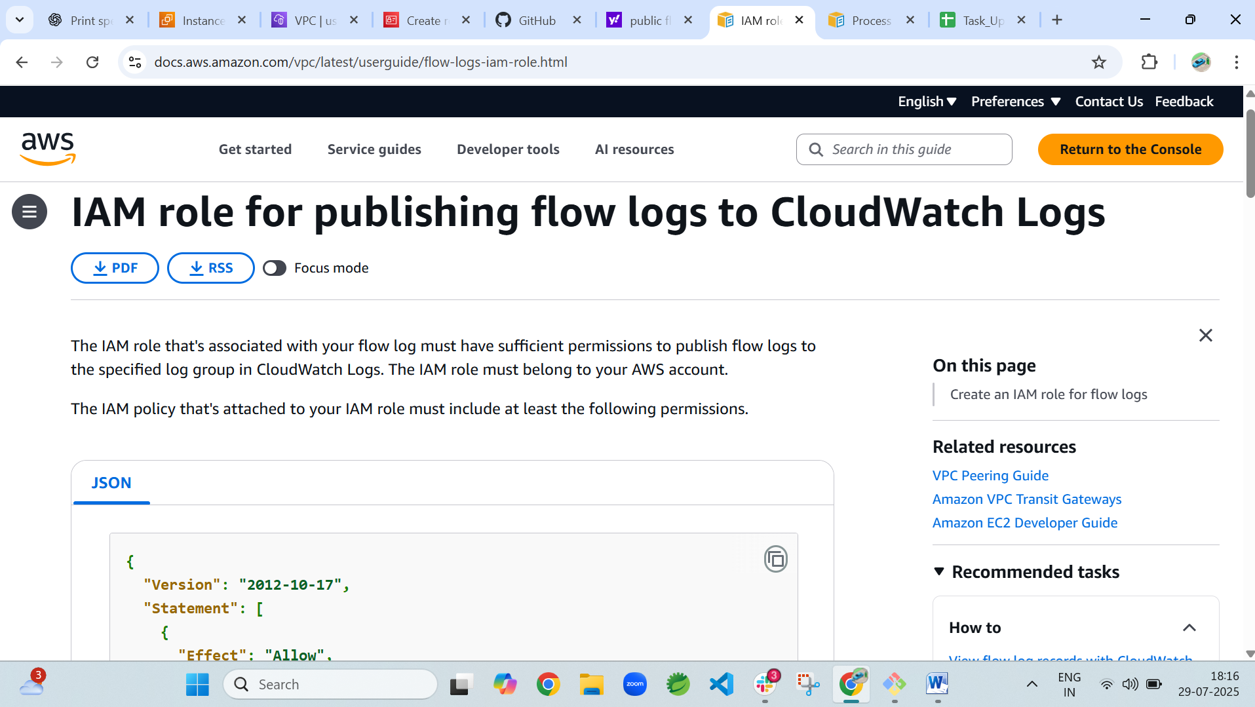

Policy create

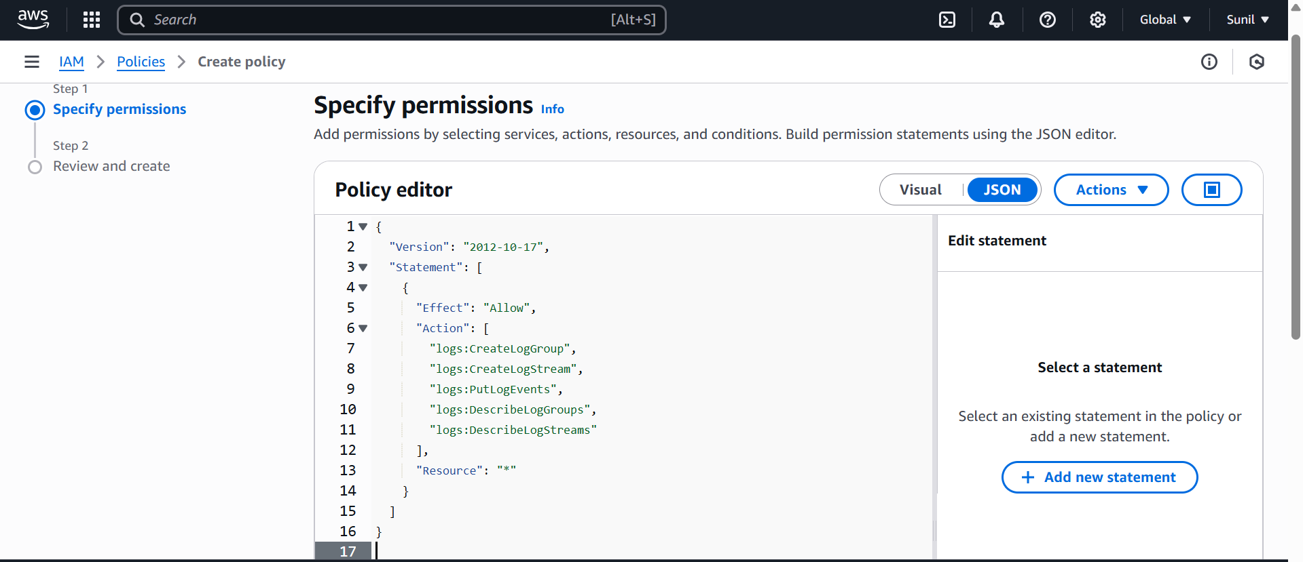

Have to create a Iam role for cloudwatch

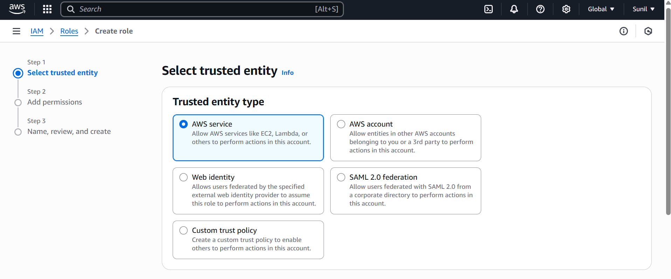

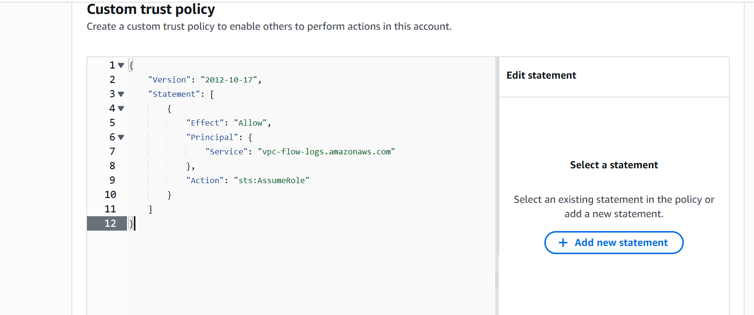

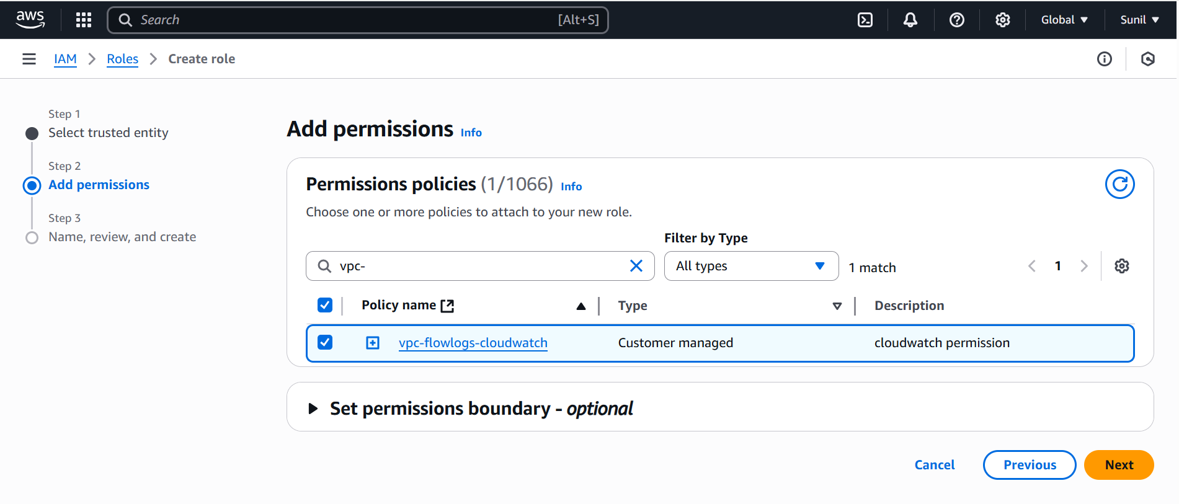

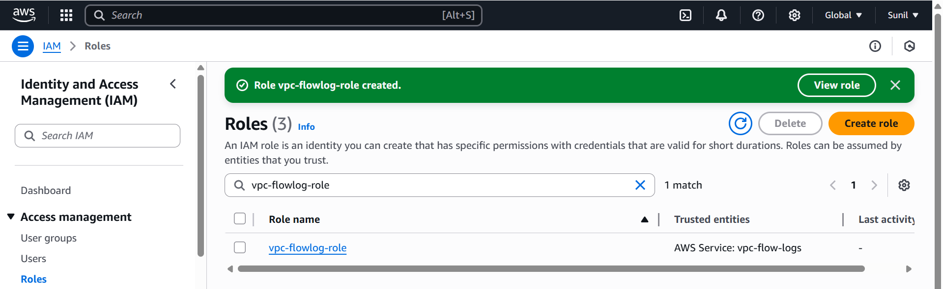

**Flow logs of cloud watch**

